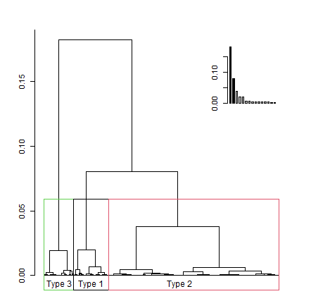
Fig.1. Dendrogram showing population clustering based on their practices and behavior from hierarchical clustering on principal components. The dashed line shows selected cut-off points.
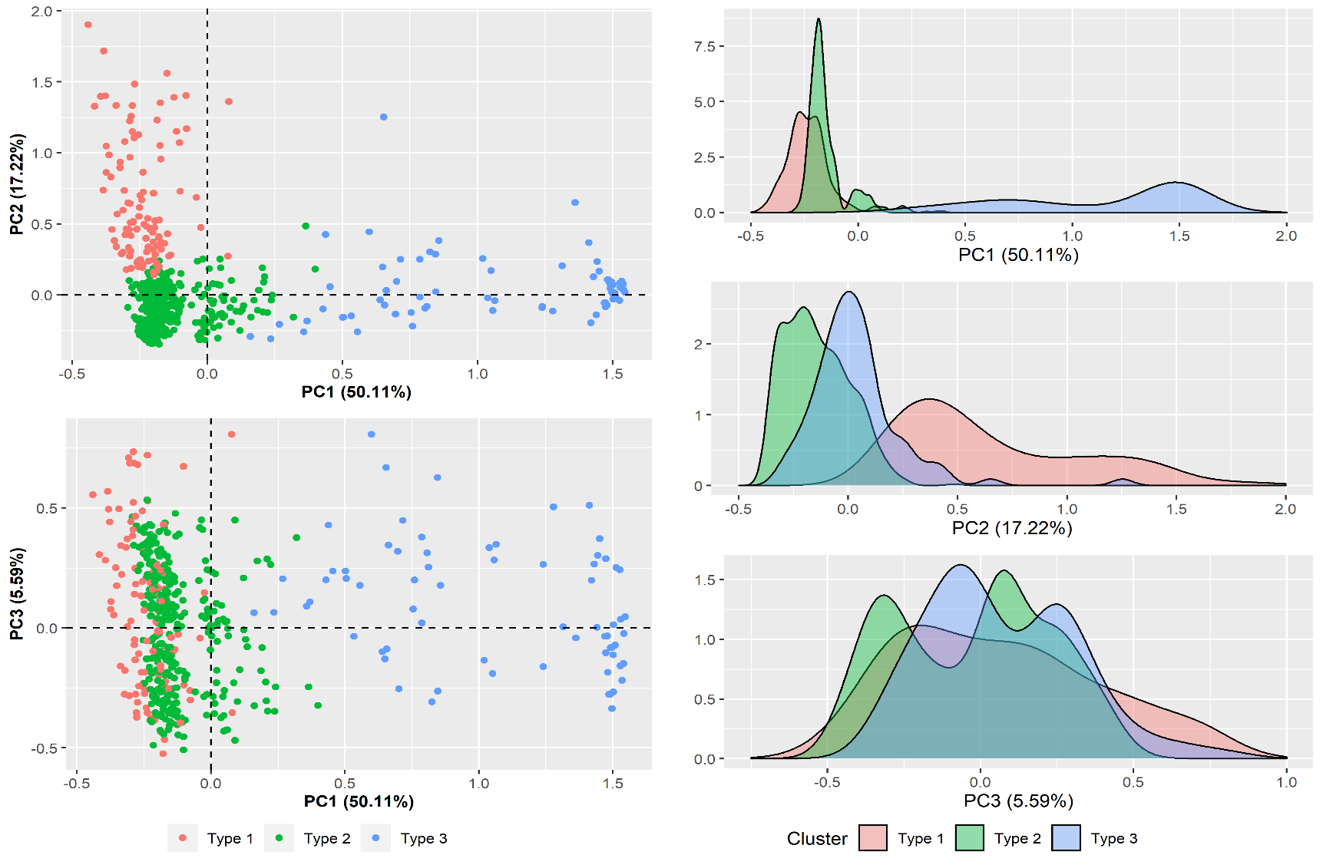
Fig. 2. Characterization of types on the main components from multiple correspondence factorial analysis

